Engineering Journal : Yarara Team

Future Engineers category WRO2023 Argentina

***Participants****: Zayas Ana Florencia, Aguirre Franco Joaquin*

***Mentor****: Juan Jose Campis*

***Country:*** *Argentina*

This is the engineering journal of the Yarará Team, proudly representing Argentina in the WRO Panama 2023 competition. Our team consists of two dedicated students and a mentor. Hailing from the province of Misiones in the northwest of Argentina, we started our journey into the world of robotics through the ERM (Escuela de Robótica Misiones).Which is an after-school program that passionately nurtures young minds in the realms of electronics, programming, and design.

***Mobility Management***

As the regulations for the competition say, we use one dc motor and one servo motor on our robot. In order to make the steering system work, we attached a 3d printed piece which allows both front wheels to move from left to right.This system is pretty simple. However we consider it to be useful. As regards to the dc motor , we attached two wheels to the motor, that way we could make our robot way more efficient and compact.The dc motor (which is in the rear of the chassis) allows the robot to move forward and back.

***Power and Sense Management***

We took the decision to power the circuit using two batteries; one for the logical part (like the raspberry and the camera) and the other that powers the dc motor. The camera is connected to the raspberry pi while the ultrasound sensors are connected to the arduino.

We decided on the HC SR-04 sensors since we are familiarized with them when it comes to coding.In order to avoid obstacles depending on their color we used a camera connected to the raspberry pi.

|  | specific | fuction | quantity |
| --- | --- | --- | --- |
| controller board | raspberry pi 4 |  | 1 |
| controller board | esp32 |  | 1 |
| controller board | esp8266 |  | 1 |
| sensors | hc-sr04 |  | 2 |
| driver/motor controller | esp8266 Motor Shield L293DD |  | 1 |
| power supply | li-po battery 11.1v , 8 mah |  | 1 |
| camera | picam |  | 1 |
| steering wheel | servomotor mg90s |  | 1 |
| step down | xl 4016 |  | 1 |

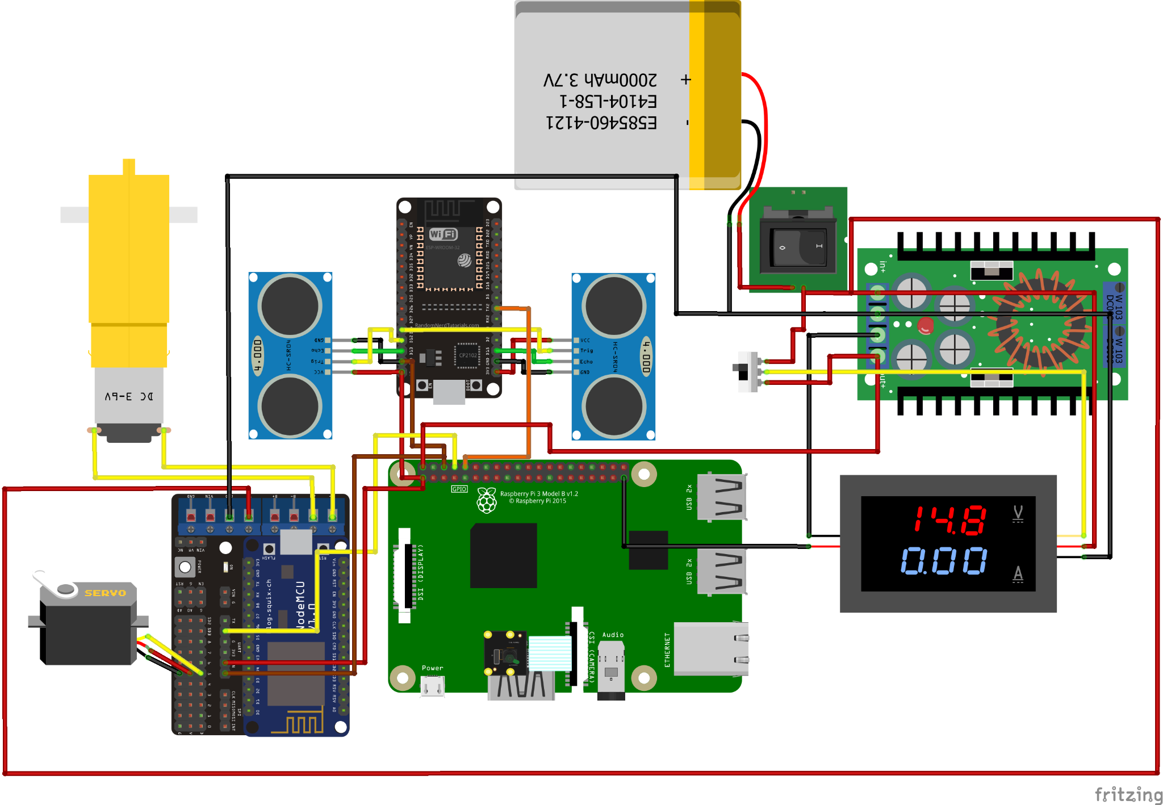

***Obstacle Management***

To prevent the robot from colliding with the walls of the future engineers' game field, we have implemented a dual HC-SR04 module system to analyze distances on both sides of the robot. This setup allows us to make real-time adjustments to the robot's position. If one side's distance reading significantly differs from the other, a servo motor will be activated to steer the vehicle in the opposite direction, re-centering it.

Additionally, we used javascript and node red code to ensure that the robot avoids collisions with both the outer and inner walls of the game field. If the robot is getting too close to a wall, it will trigger the robot to move backward and perform a spin maneuver to navigate away from the obstruction.

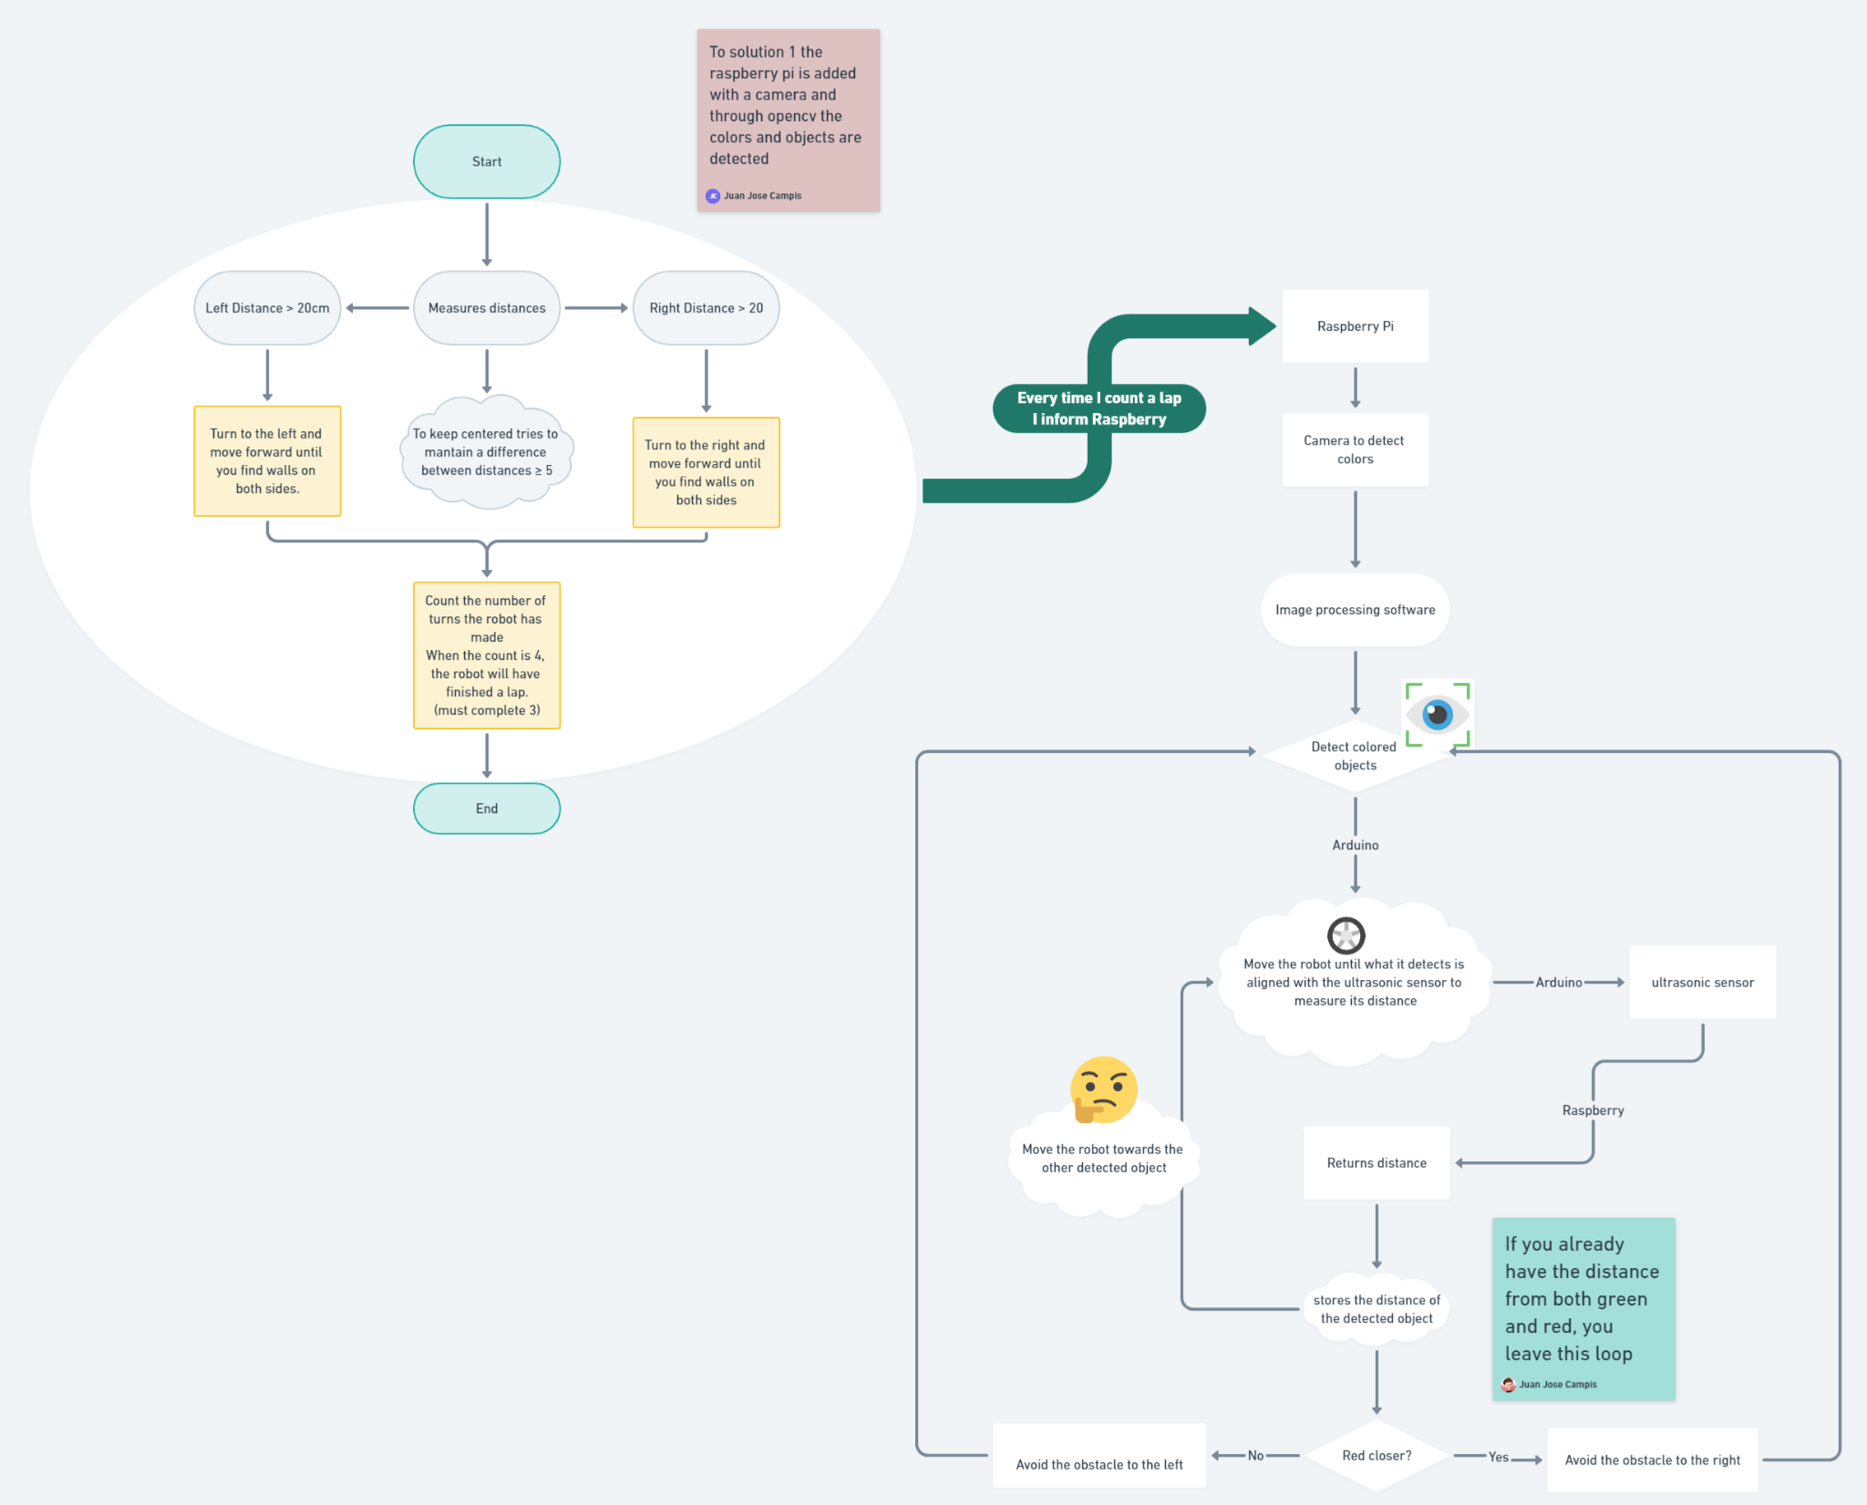

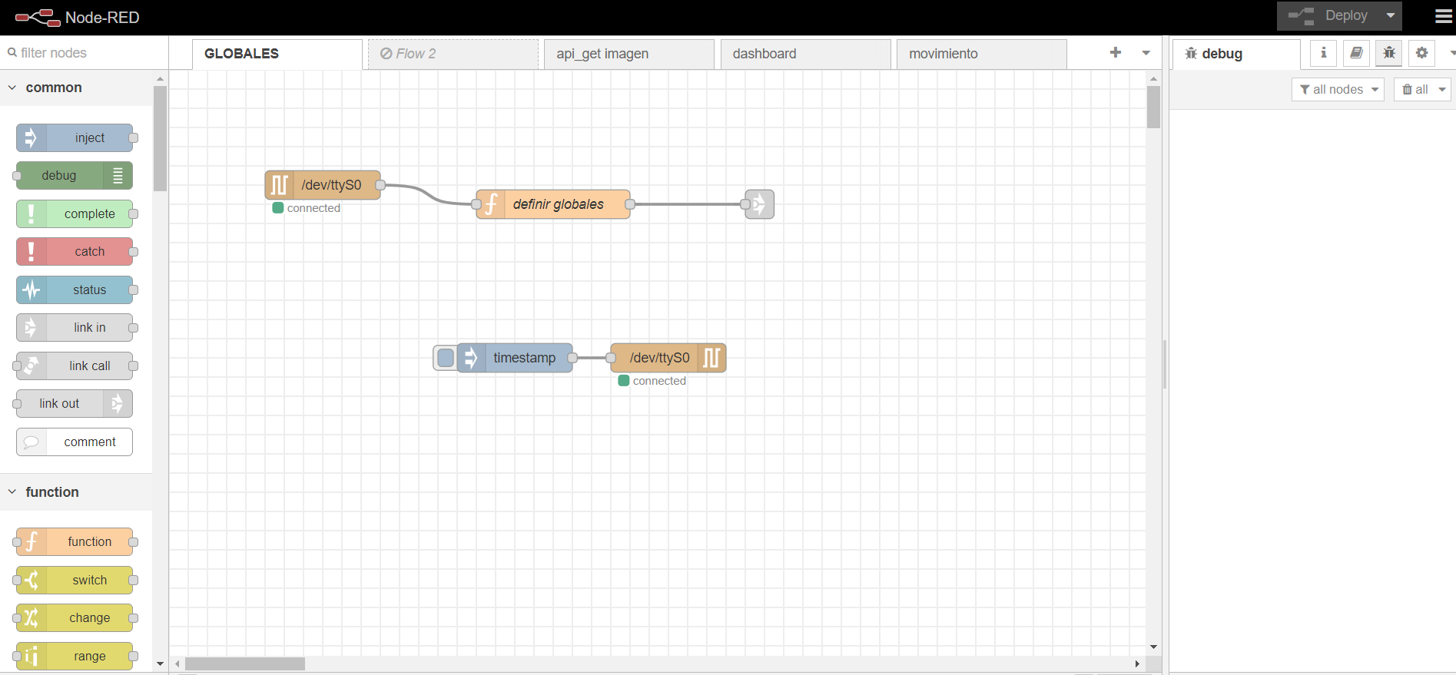

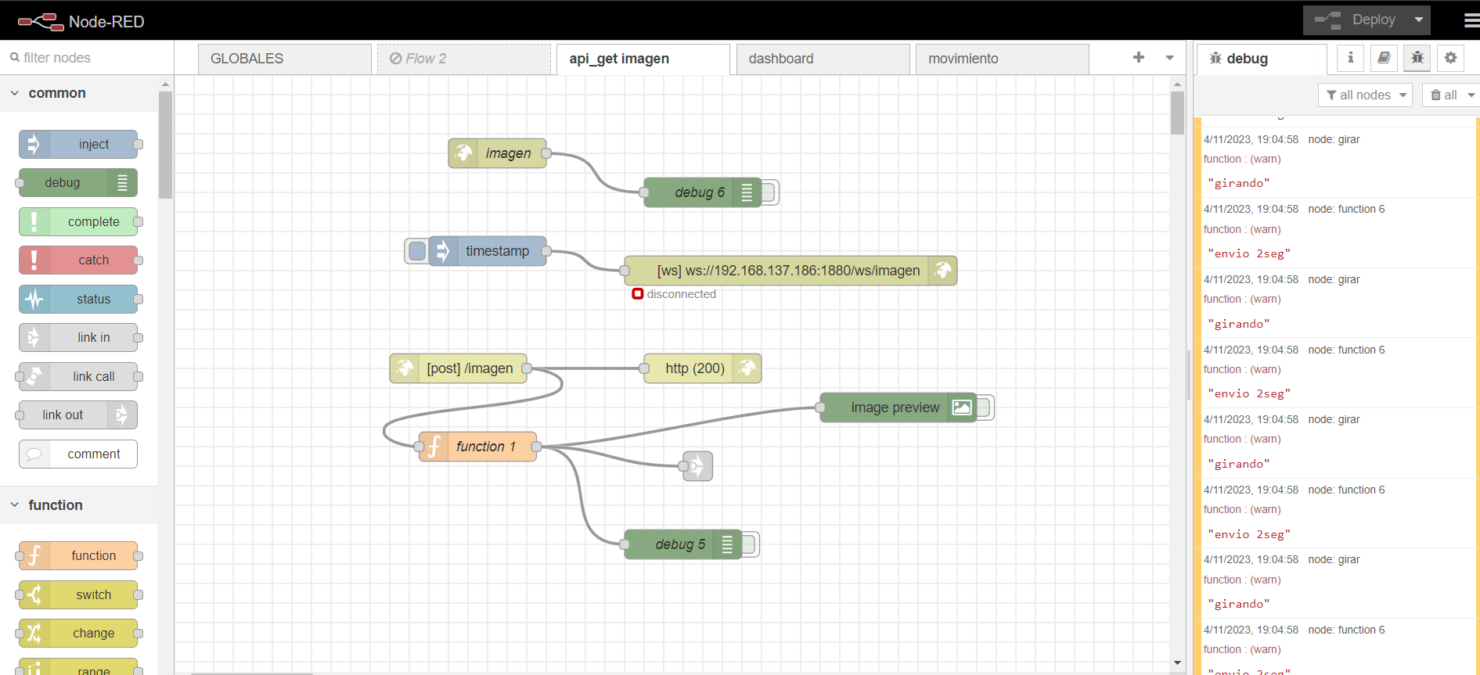

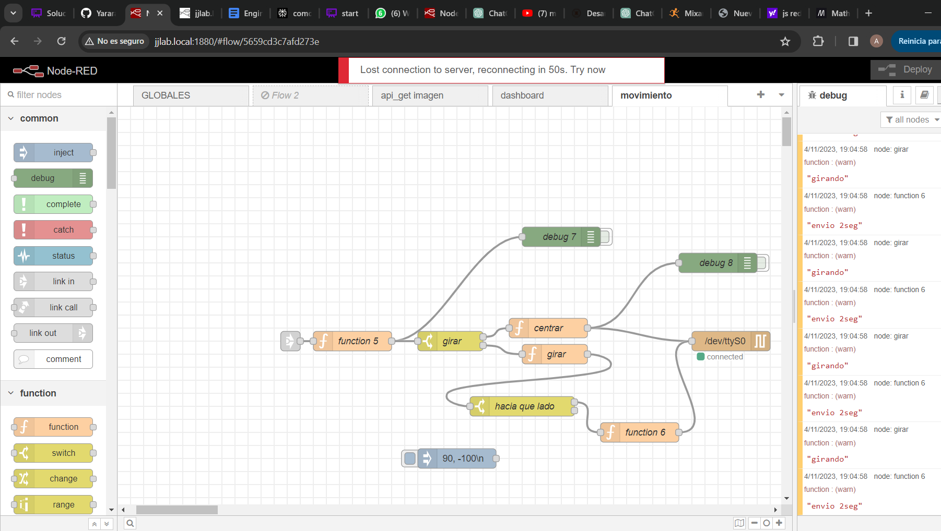

**Pictures – Team and vehicle**

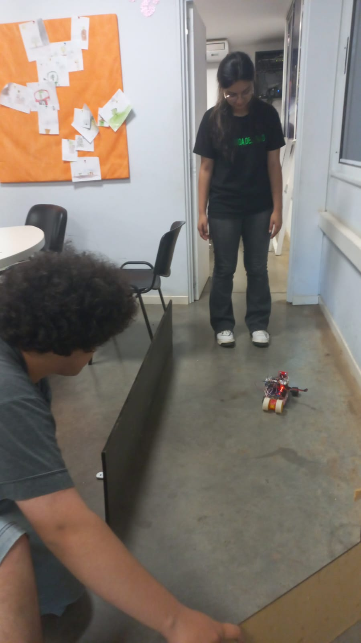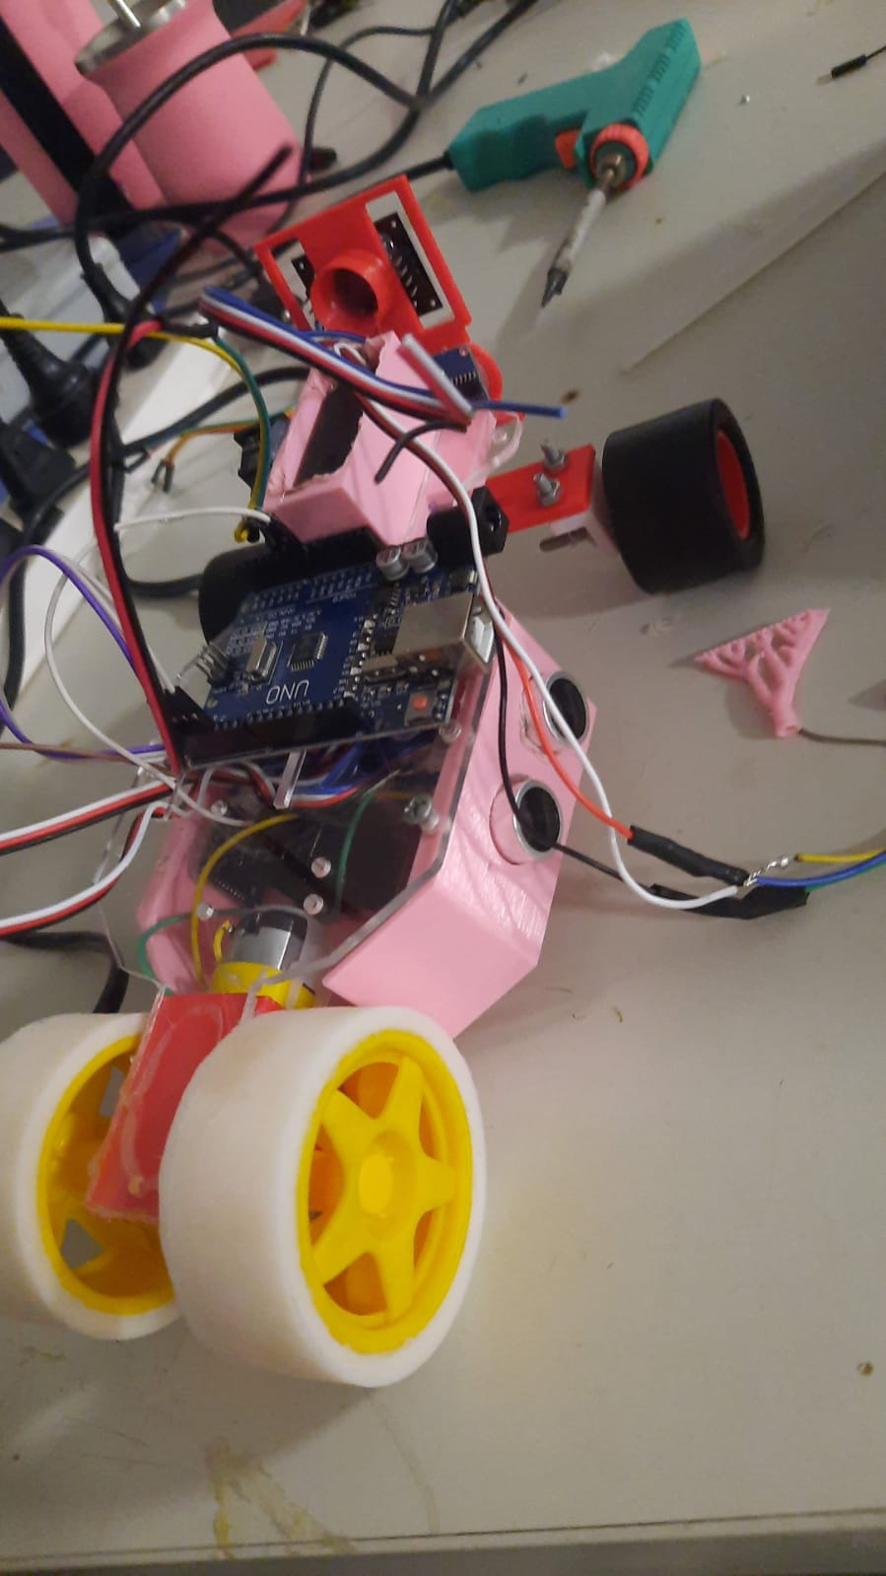

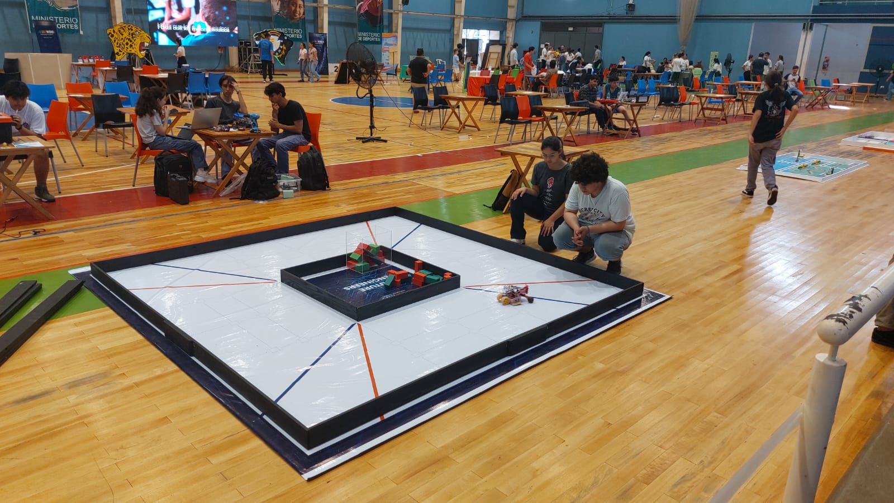

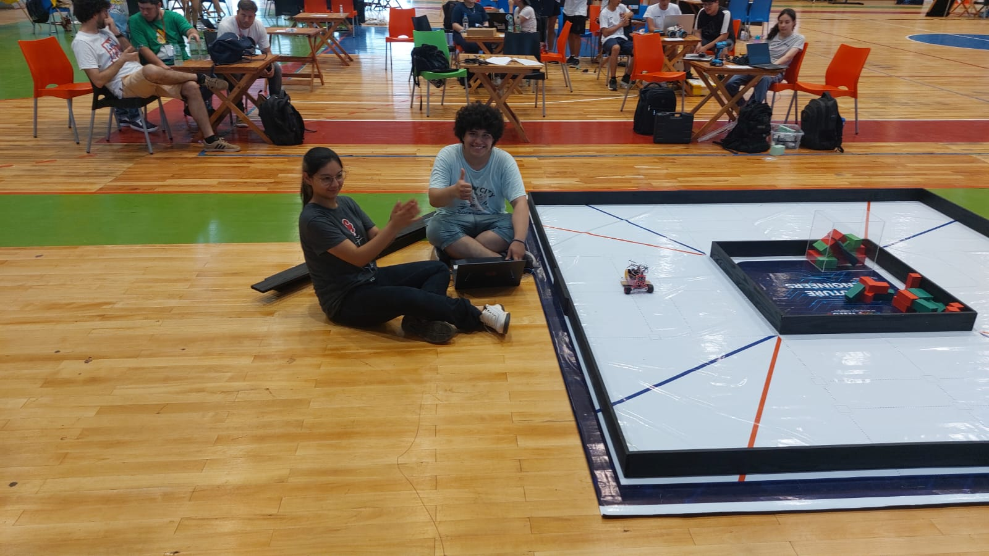

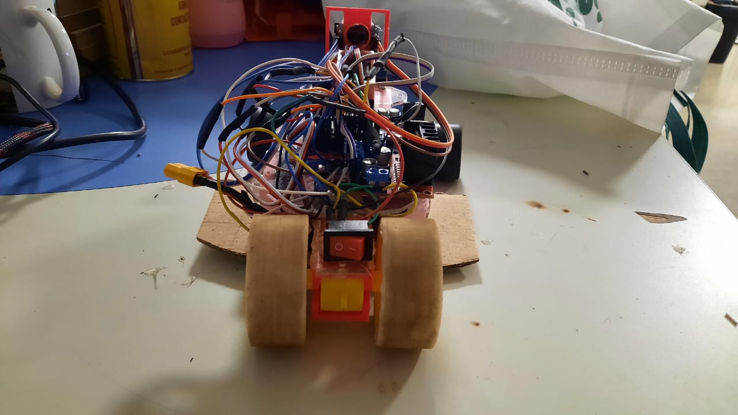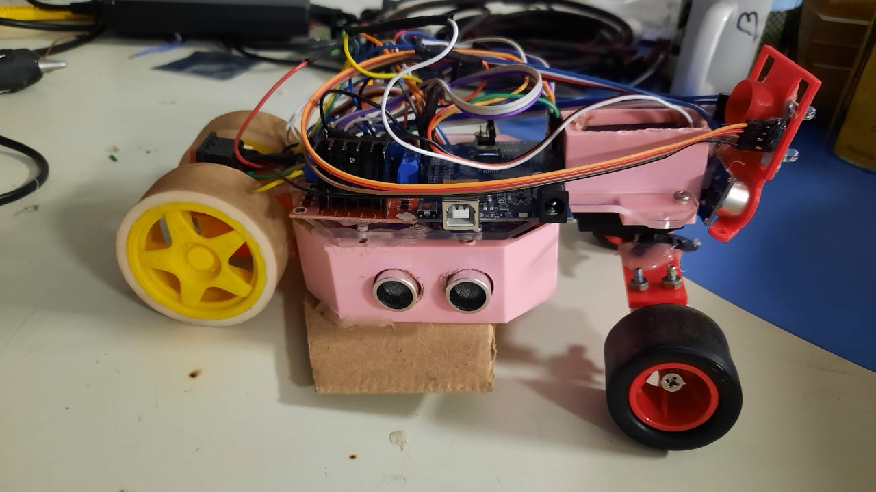

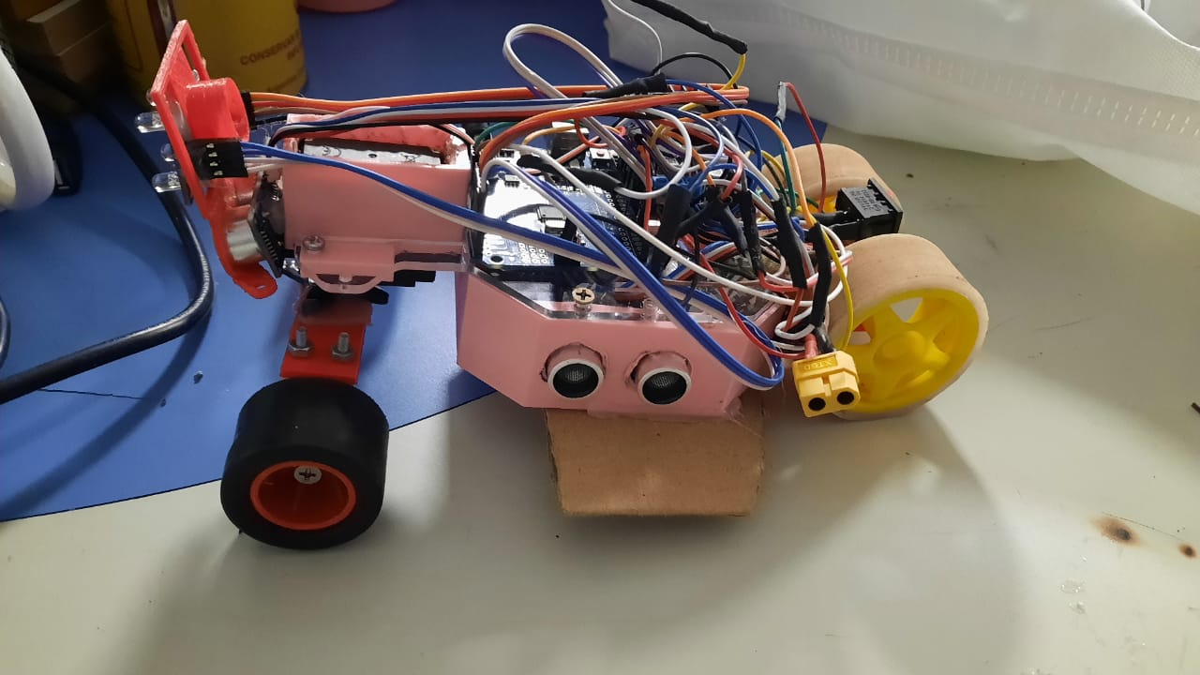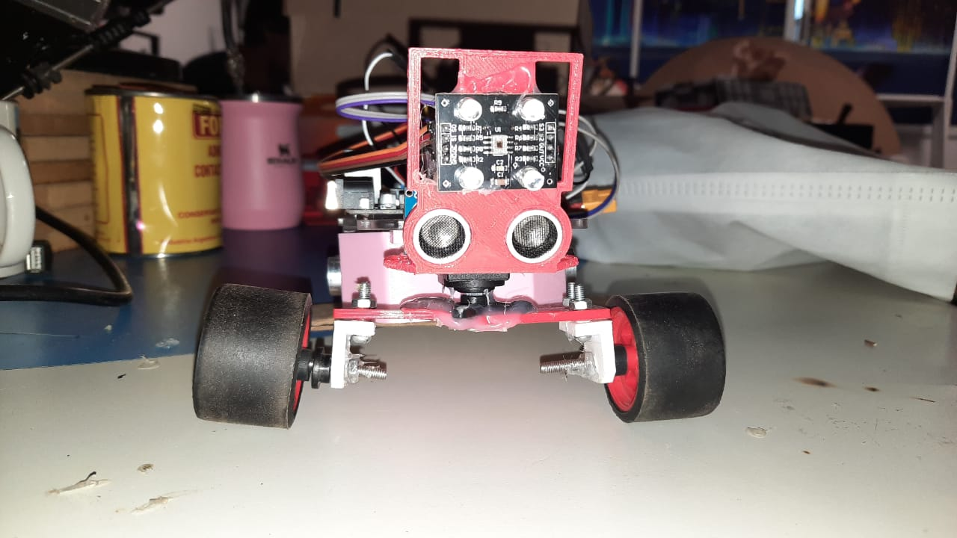

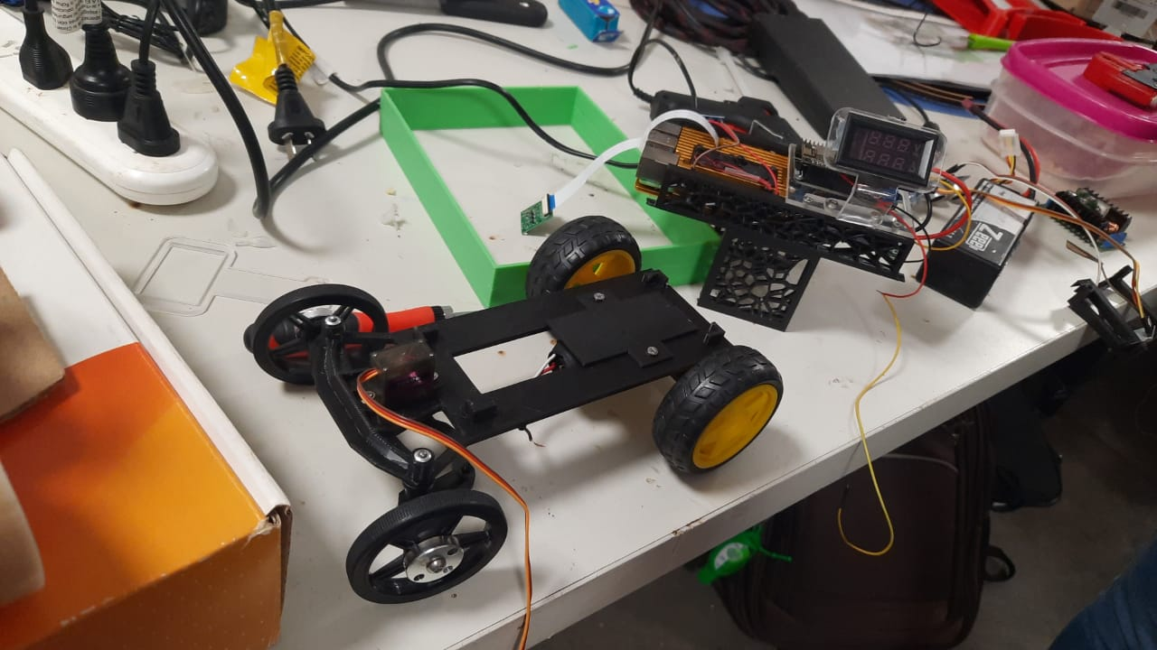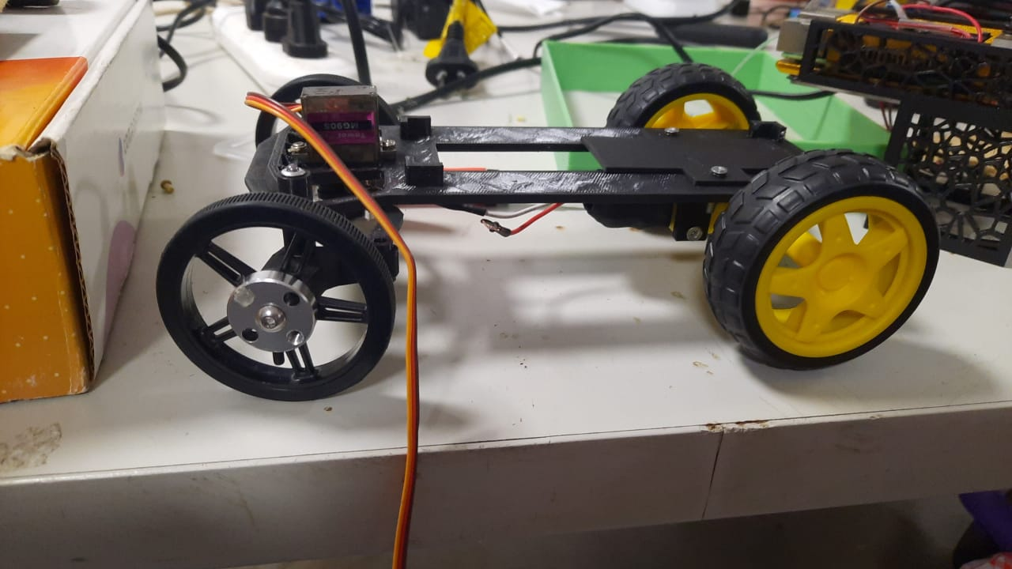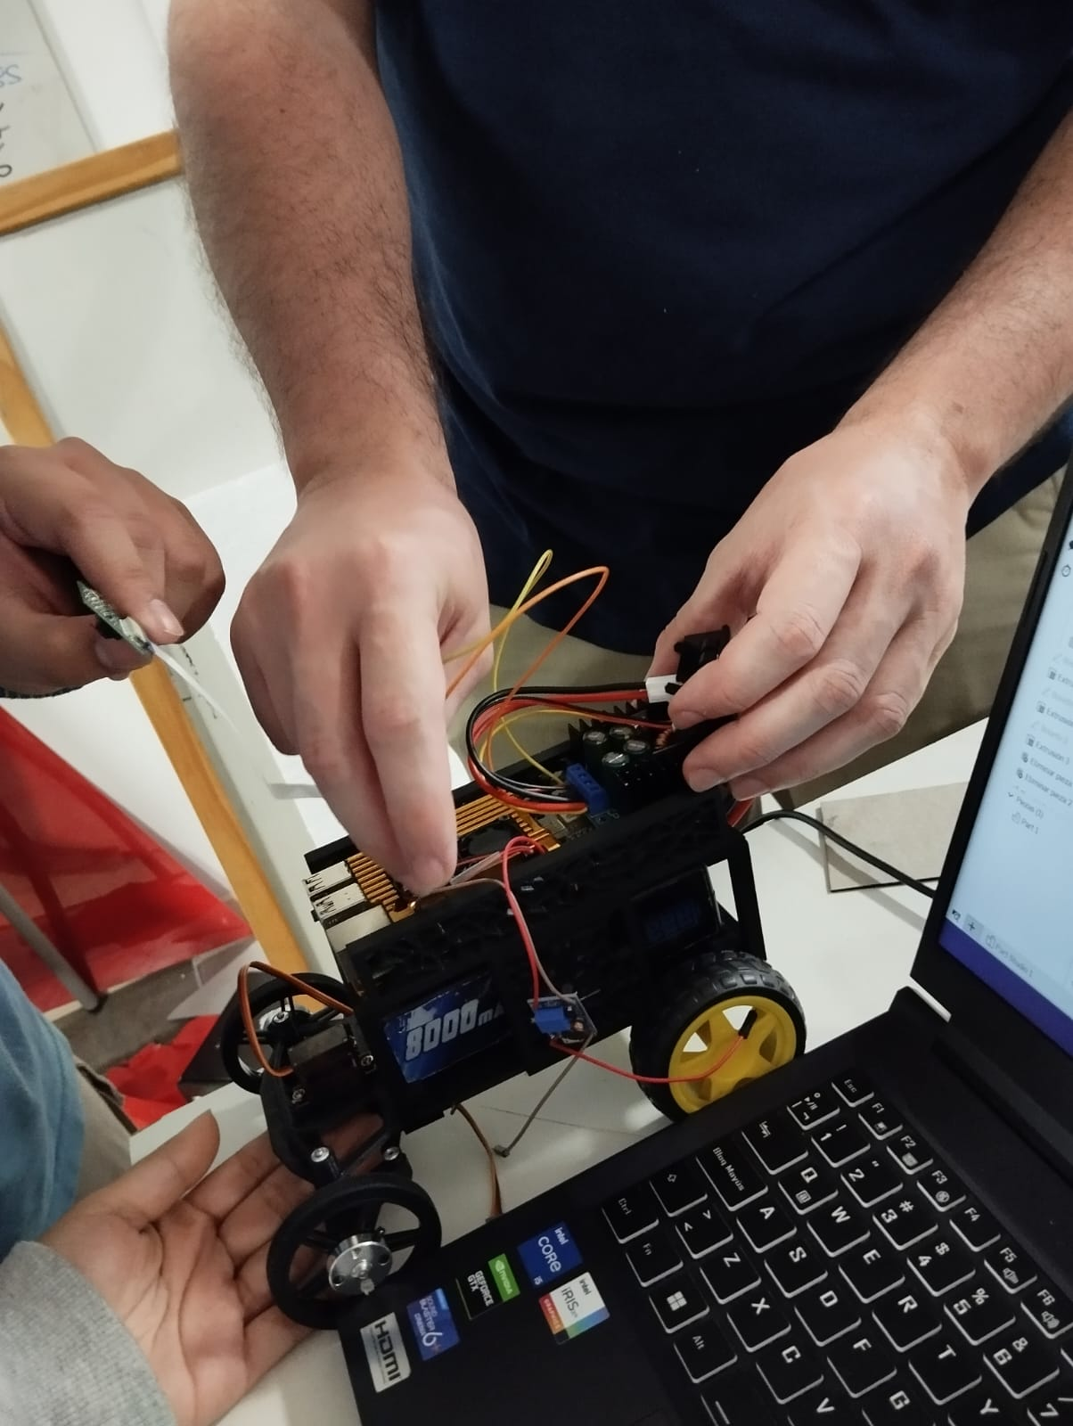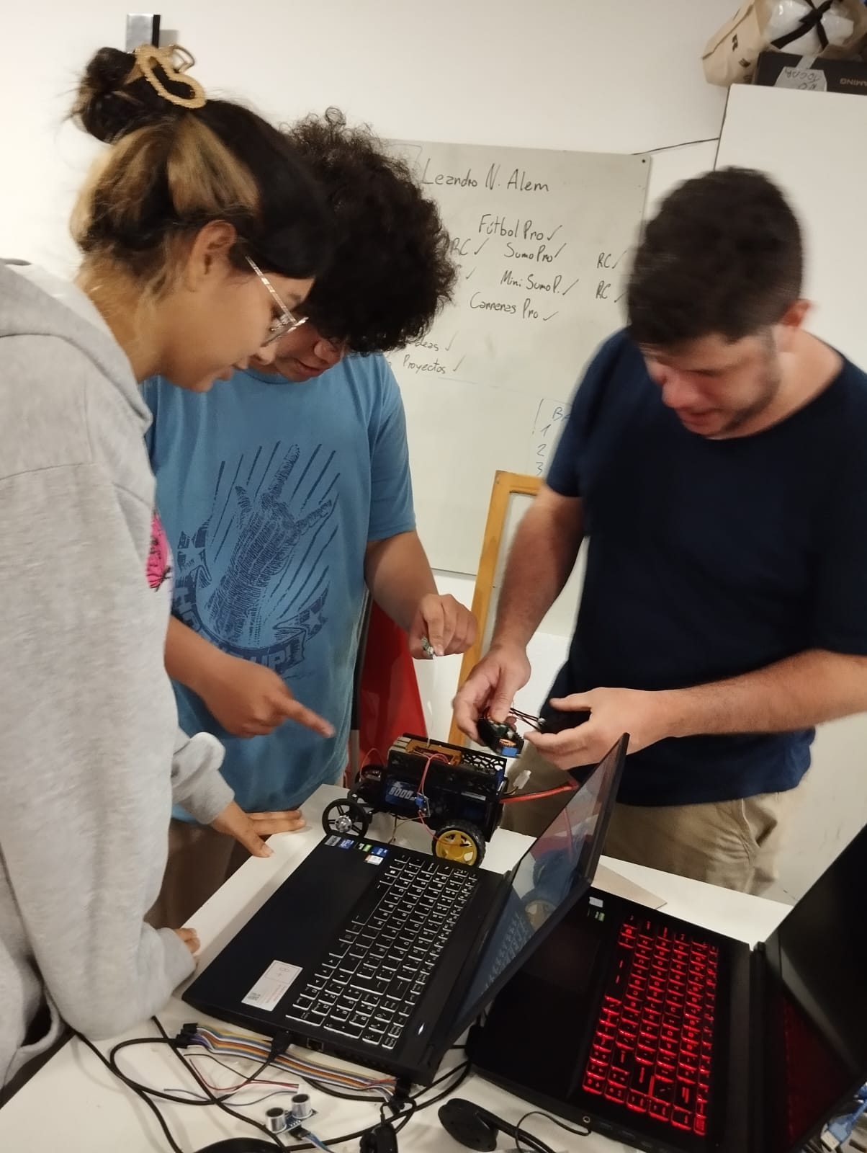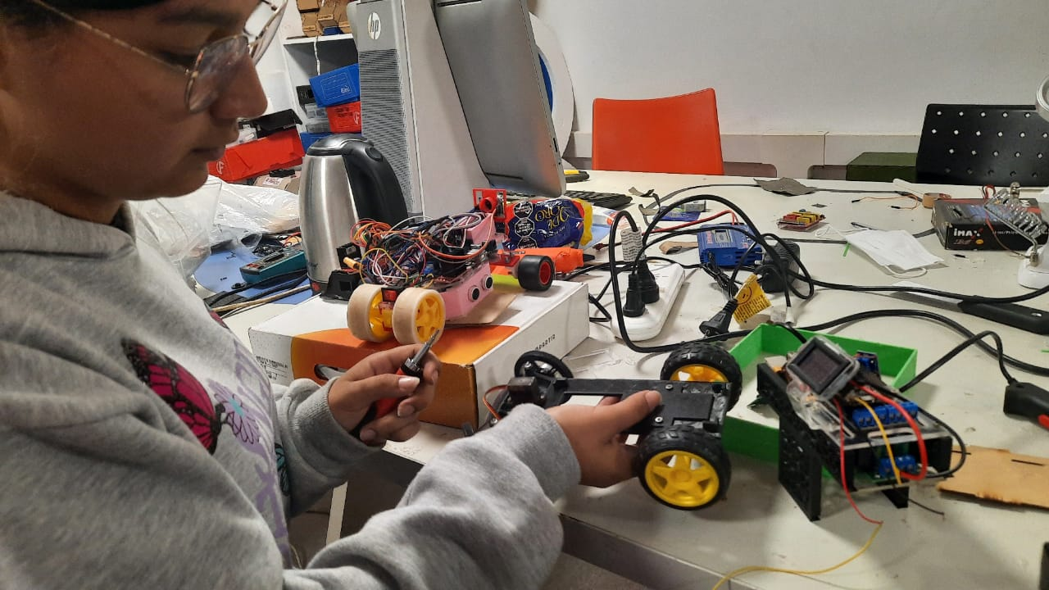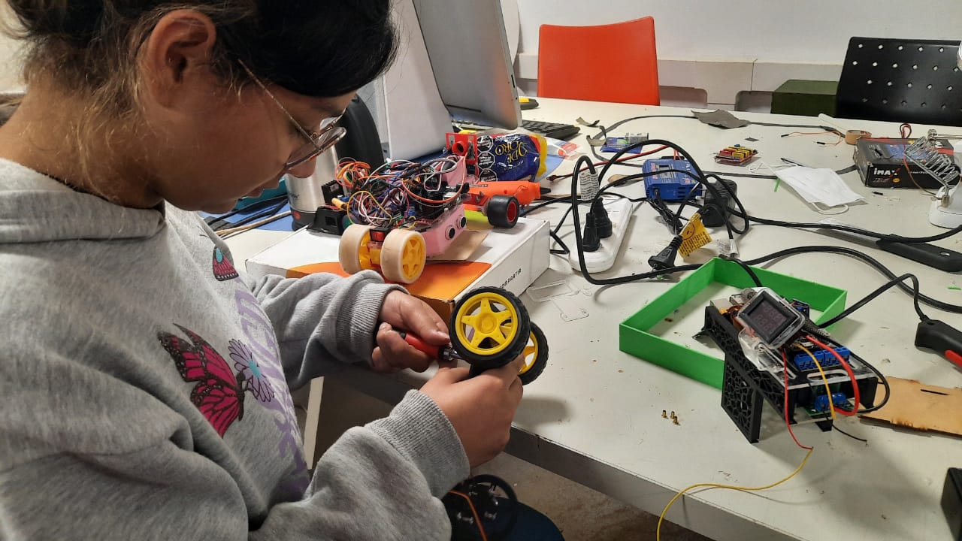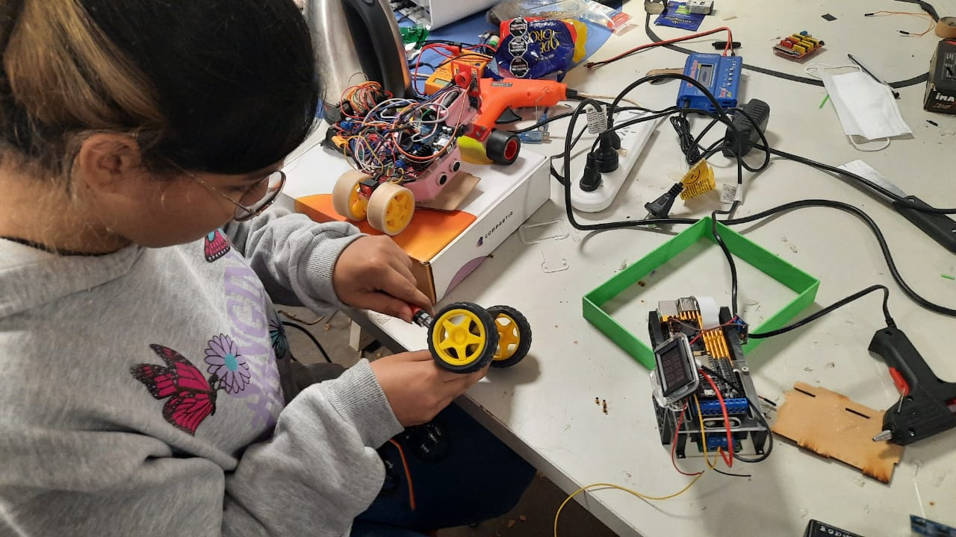

***Engineering Factor***

As newcomers to the World Robot Olympiad (WRO), we approached this challenge with some uncertainty. To assemble our robot, we drew upon our prior experiences with various components. For instance, we initially utilized an Arduino Uno for our first prototype, a platform with which we were very familiar. We also employed the "yellow plastic gearmotor" in our initial setup.

However, after conducting extensive research on different platforms and observing various techniques used by other teams, we had an innovative breakthrough. We decided to make significant changes to our setup. We replaced the Arduino Uno with a Raspberry Pi 4, and we incorporated both an ESP32 and an ESP8266 into our design. We established a serial communication system among these boards to enhance the efficiency of our robot's response during the challenges.

Specifically, we connected the HC-SR04 sensors to the ESP32, which collects data and transmits it to the Raspberry Pi. The Raspberry Pi, in turn, instructs the ESP8266 to control the DC motor and servo motor, allowing us to execute precise and coordinated movements in response to the challenges we encounter.